Interreg IPA Cross-Border Programme CCI Number CCI2014TC16I5CB006
Project: "Social Entrepreneurship Ecosystem Development" CB006.2.31.040
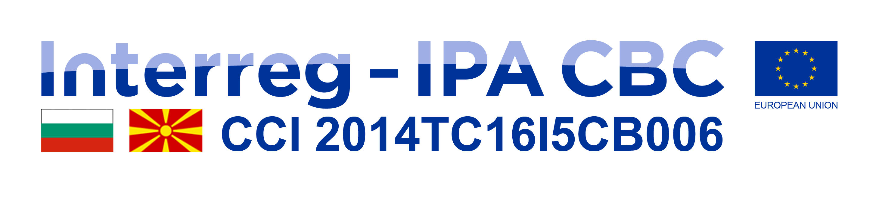

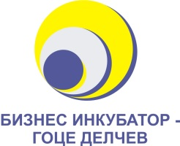


Invitation

Project “Social Entrepreneurship Ecosystem Development”

Dear All,

Foundation for Development of Small and Medium Enterprises - Strumica invites you on November 26 and 27, 2020 at Hotel Sirius (conference room) - Strumica, starting at 10:00 to an Cross-border Conference on Social Entrepreneurship - ,,Challenges and social impact of Social Entrepreneurship the BG-MK cross-border region " which is part of the project “Social Entrepreneurship Ecosystem Development “

The aim of this conference is to inform the general public with all activities implemented by the project, to present the most successful social ideas translated into business plans, to bring together representatives of public authorities, businesses, schools, universities, NGOs, media in order to raise awareness of the region's opportunities for social economy and discuss its challenges and perspectives.

Regarding the situation caused by the spread of KOVID-19, the Cross-border Conference will be held in accordance with all anti-epidemic measures and with the recommendations of the authorized health bodies.

Project is co-financed by the EU through the Interreg-IPA Cross-Border Cooperation Program between the Republic of North Macedonia and the Republic of Bulgaria and implemented in partnership with Business Incubator - Entrepreneurship promotion centre from Goce Delchev - R. Bulgaria.

For more detailed information you can contact us at:
phone 034-349-320 or e-mail: rcsr@t.mk

We look forward to your presence.

With respect,
Foundation for Development of Small and Medium Enterprises - Strumica

