Interreg IPA Cross-Border Programme CCI Number CCI2014TC16I5CB006
Project: "Social Entrepreneurship Ecosystem Development" CB006.2.31.040
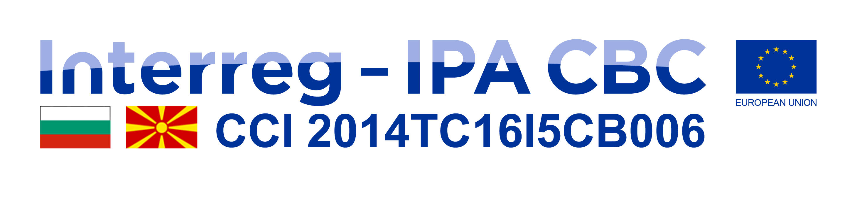




Invitation

Project “Social Entrepreneurship Ecosystem Development “

Dears,

Foundation for Development of Small and Medium Enterprises - Strumica invites you to a first Cross-border Social Entrepreneurship Marketplace under the project "Social Entrepreneurship Ecosystem Development", which is implemented in partnership with Business Incubator - Center for Entrepreneurship support from Goce Delchev - R.Bulgaria . The project is co-financed by the EU, through the Interreg-IPA Cross-Border Cooperation Program between R.N. Macedonia - R.Bulgaria.

The Social Entrepreneurship Marketplace will be held on November 19 - 20, 2020 (Thursday, Friday), in hotel "Sirius" (conference hall) -Strumica starting at 12.00p.m.

The aim of the Social Entrepreneurship Marketplace is presentation 16 (8 Mk and 8 Bg) social business ideas to potential investors, social businesses, institutions and organizations that support them, as well as stakeholders - public authorities, NGOs, the community.

We look forward to your presence.
With respect,

Foundation for Development of Small and Medium Enterprises - Strumica

