Interreg IPA Cross-Border Programme CCI Number CCI2014TC16I5CB006
Project: "Social Entrepreneurship Ecosystem Development" CB006.2.31.040
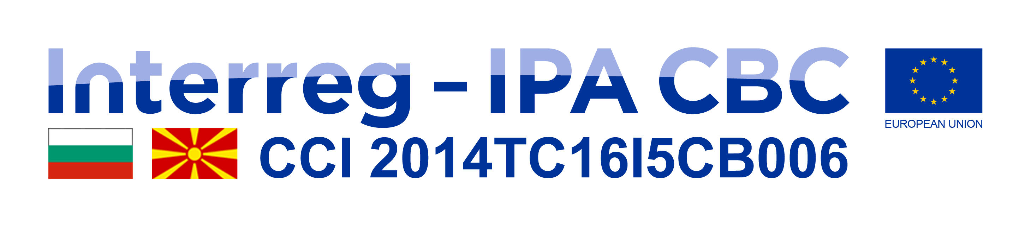




Invitation

Project “Social Entrepreneurship Ecosystem Development “

Dear,
The Foundation for Development of Small and Medium Enterprises - Strumica invites you to a three-day workshop on ecosystem for social entrepreneurship after the project "Development of ecosystem for social entrepreneurship", which is implemented in partnership with Business Incubator - Center for Entrepreneurship from Goce Delchev .Bulgaria. The project is co-financed by the EU, through the Interreg-IPA Cross-Border Cooperation Program between RS Macedonia - R.Bulgaria.

The workshop will be held on October 20-22, 2020 (Tuesday, Wednesday, Thursday), at the hotel "Sirius" (conference hall) -Strumica starting at 12.00.
The aim of the workshop is to present and discuss the concept of the social entrepreneurship ecosystem in the cross-border region Bulgaria - Macedonia, successful European social entrepreneurship practices, social innovation, benefits and impact of social entrepreneurship for target groups, especially youth, society and social economy, challenges and potential in the cross-border region, policies and support instruments, opportunities to create a favorable environment for a functioning ecosystem.

We look forward to your presence.

With respect,
Foundation for Development of Small and Medium Enterprises - Strumica

